**A**

**DOMAIN SPECIFIC MINI PROJECT REPORT**

**ON**

**“Object Detection”**

SUBMITTED IN PARTIAL FULFILLMENT OF THE DEGREE

**BACHELOR OF TECHNOLOGY**

**SHIVAJI UNIVERSITY, KOLHAPUR**

SUBMITTED BY

Aniket Mohan Patil [49]

Pratik Sunil Patil [51]

Swapnali Sambhaji Patil [60]

Neha Vijay Powar [65]

DEPARTMENT OF COMPUTER SCIENCE AND ENGINEERING

**UNDER THE GUIDANCE OF**

**Prof. A. V. Surve**



DEPARTMENT OF COMPUTER SCIENCE AND ENGINEERING

**TATYASAHEB KORE INSTITUTE OF ENGINEERING AND TECHNOLOGY,**

**WARANANAGAR**

**Academic Year 2020-2021**

**TATYASAHEB KORE INSTITUTE OF ENGINEERING AND TECHNOLOGY,**

**WARANANAGAR**

DEPARTMENT OF COMPUTER SCIENCE AND ENGINEERING



**CERTIFICATE**

*This is to certify that the project work entitled*

**“Object Detection”**

*Submitted by*

|  |  |
| --- | --- |
| **Name** | **Roll No.** |
| **Aniket Mohan Patil** | **49** |
| **Pratik Sunil Patil** | **51** |
| **Swapnali Sambhaji Patil** | **60** |
| **Neha Vijay Powar** | **65** |

of third year Computer Science and Engineering TKIET, Warananagar, in partial fulfillment for the award of bachelor degree in Computer Science and Engineering from Shivaji University, Kolhapur. It is certified that all corrections/suggestions indicated for internal assessment have been incorporated in the report. This project work is a record of students' own work, carried out by them under our supervision and guidance during the academic year 2020-2021.

Dr. G. V. Patil Prof. R. G. Hiregoudar Prof. Guide Name

(Head of Department) (DSMP Co-ordinator) (Project Guide)

Dr. S. V. Anekar

(Principal ) (Internal Examiner) (External Examiner)

Date: ___________

**ACKNOWLEDGEMENT**

This space is dedicated to acknowledge all those who have helped in bringing this project to fruition.

We are greatly indebted to our guide **Prof. A. V. Surve** and DSMP Coordinator **Prof. R. G. Hiregoudar** for his/her unstinted support and valuable suggestions. We are grateful to them not only for the guidance, but also for their unending patience and keeping our spirits high throughout. We express our sincere thanks to our beloved Head of the Department, **Dr. G. V. Patil** and Principal, **Dr. S. V. Anekar** for being a source of inspiration and providing us the opportunity to work on this project.

We extend heartfelt thanks to all the **teaching** and **non-teaching staff** of the department of computer science and system and network support of TKIET for their assistance and cooperation

Finally, we would like to thank our parents and friends for their moral support and encouragement throughout our academics

**Student names Roll No Signature**

**Aniket Mohan Patil 49**

**Pratik Sunil Patil 51**

**Swapnali Sambhaji Patil 60**

**Neha Vijay Powar 65**

**ABSTRACT**

Object detection methods aim to identify all target objects in the target image and determine the categories to achieve machine vision understanding. Numerous approaches have been proposed to solve this problem, mainly inspired by methods of computer vision and deep learning. In this study, we compare and analyze YOLO (You Only Look Once) object detection algorithms.

**INDEX**

**Chapter 1: Introduction**

* + - * 1. 1.1 Domain Information
    1. 1.2 Survey of similar work
  1. 1.3 Motivation

**Chapter 2: Problem definition and scope**  2.1 Problem Statement

2.2 Objective

2.3 Technologies and Associated Platforms

**Chapter 3: Requirement Analysis**

3.1 Design Requirements

3.2 Functional Requirements

3.3 Non Functional Requirements

**Chapter 4: Design Methodology**

4.1 System Architecture

4.2 DFD Diagrams

4.3 UML Diagrams

**Chapter 5: Module Implementation Details**

**Chapter 6: Test Specification**

6.1 Introduction

6.2 Testing Strategy

**Chapter 7: System Design and Implementation**

6.1 GUI Screenshots

**Chapter 8: Conclusion and Future Work**

7.1 Conclusion

7.2 Future Work

**References**

**Chapter 1**

# INTRODUCTION

**1.1** **Domain Introduction:**

**1.1.1 Machine learning:**

We all are human. We learn from experiences. From the day we born, we start

learning things. As we grow up, we start learning how to stand on our feet and walk.

We listen to the people around us and try to speak the same. We learn the meaning

of different words. What to say when we are hungry or need something. We also

start classifying things as good and bad. For example, when we go near to the fire

the first time, we feel the heat, and we come back. We learn not to go too close to the

fire.

Now think about the working of a computer. It follows the instruction given by

humans. It can process millions of instructions in a second and return the result. It

can perform the task described by humans but cannot take decisions by itself.

Here comes machine learning in action. What will happen if we will give

computer ability to think like a human? Isn’t it Awesome? We can give every day’s

action in a format that computer can understand and do a math around it and

build some model that will help it take actions in future.

So, humans learn from experience and computers follow instruction. Instead we

can give experience directly to computers to learn and prepare itself for action.

Now we define the experience in a structured format. So, we say computer learn

from data (Experience) and this process is called Machine Learning.

**1.1.2 Deep Learning:**

Deep learning is a branch of machine learning which is completely

based on artificial neural networks, as neural network is going to mimic the human

brain is so deep learning is also a kind of mimic of the human brain.

In deep learning, we don’t need to explicitly program everything. The

concept of deep learning is not new. It has been around for a couple of years now. It’s

on hype nowadays because earlier we did not have that much processing power and a

lot of data. As in the last 20 years, the processing power increases exponentially, deep

learning and machine learning came into the picture. A formal definition of deep

learning is- neurons Deep learning is a particular kind of machine learning that

achieves great power and flexibility by learning to represent the world as a nested

hierarchy of concepts, with each concept defined in relation to simpler concepts, and

more abstract representations computed in terms of less abstract ones. In human brain

approximately 100 billion neurons all together this is a picture of an individual

neuron and each neuron are connected through thousands of their neighbor’s. The

question here is how do we recreate these neurons in a computer.

So, we create an artificial structure called an artificial neural net where we

have nodes or neurons.We have some neurons for input value and some for output

value and in between, there may be lots of neurons interconnected in the hidden

layer.

**1.1.3 OpenCV (Open Computer Vision):**

OpenCV stands for Open supply pc Vision Library is associate open supply

pc vision and machine learning software system library. The purpose of creation of

OpenCV was to produce a standard infrastructure for computer vision applications

and to accelerate the utilization of machine perception within thebusiness product. It

becomes very easy for businesses to utilize and modify the code with OpenCV as it is

a BSD-licensed product. It is a rich wholesome library as it contains 2500 optimized

algorithms, which also includes a comprehensive set of both classic and progressive

computer vision and machine learning algorithms. These algorithms are used for

various functions such as discovering and acknowledging faces. Identifying objects

classifies human actions. In videos, track camera movements, track moving objects.

Extract 3D models of objects, manufacture 3D purpose clouds from stereo cameras,

sew pictures along to provide a high-resolution image of a complete scene, find

similar pictures from a picture information, remove red eyesfrom images that are

clicked with the flash, follow eye movements, recognize scenery and establish

markers to overlay it with augmented reality.

**1.2 Survey of similar work**

|  |  |  |  |  |
| --- | --- | --- | --- | --- |
| **Sr no** | **Title** | **Author** | **Year** | **Description** |
| 01 | How to Perform Object Detection With YOLOv3 in Keras | Jason Brownlee | May 27,2019 | Object detection is a task in computer vision that involves identifying the presence, location, and type of one or more objects in a photograph. |
| 02 | Comparative Study of Face and Person Detection algorithms: Case Study of tramway in Lyon | Hatem BELHASSEN , Virginie FRESSE | 25 August 2019. | A simple way different techniques for face and person detection able to satisfy our requirements and that could be embedded on the tramway |
| 03 | Visual Object Detection and Tracking using YOLO and SORT | Shah Nazir | Nov-  2019. | Computer vision has received a great deal of coverage, Visual object tracking is one of the most important areas of computer vision. |
| 04 | Object Detection through Modified YOLO Neural Network Tanvir Ahmad | Yinglong Ma, Muhammad Yahya | 2020 | Human beings can detect and recognize multiple objects in images or videos with ease regardless of the object’s appearance |

**Table 1: Comprising study of survey**

**1.2.1 Existing system**

There are some existing object detection systems using R-CNN, Fast R-CNN and Faster R-CNN. These systems are very accurate but the speed of these systems is slow.

**1.2.2 Drawback of Existing System**

Existing systems always perform poorly for the detection of small, dense objects, and even fail to detect objects with random geometric transformations.

**1.3 Motivation**

The basic motivation behind this project is that it is something that will overdo all virtual tasks. It is of interest as it may help humans to be aware of minute information about particular objects and reduce human tasks. Object detection is breaking into a wide range of industries, with use cases ranging from personal security to productivity in the workplace. Object detection and recognition is applied in many areas of computer vision, including image retrieval, security, surveillance, automated vehicle systems and machine inspection.

**Chapter 2**

**PROBLEM DEFINITION AND SCOPE**

**2.1 Problem statement**

A computer vision approach to solving the problem starts with detecting and identifying objects in the scene. This problem corresponds to determining the regions within an image or video sequence containing objects. The usual representation of such regions is a rectangular bounding box as object detection results

**2.2 Objective**

* Identify and locate objects in an image or videos.
* Detect multiple objects using a single neural network.
* Locate objects with a Bounding box.
* Reduce human tasks

**Chapter 3**

**REQUIREMENT ANALYSIS**

**3.1 Design Requirements**

Design is one of the important stages in software engineering. This stage is the first step in moving from problem to the solution domain. In other words, starting with what is needed, design takes us to work on how to satisfy the needs.

* As the user provides the Image, Video, Live Video by providing the path to the system thus the user interface is not required for this stage.
* An interface is required for showing the output of the processed Image/Video/Live Video

**3.2 Functional Requirements**

Functional requirements define the basic system behavior i.e. what the system should do or does not do.

* As our system receives Image/Video/Live Video for the user by the path given to it, as the system only process blobs and OpenCV only processes RGB colors the input should be converted.
* One object should form one or many bounding boxes around it.

**3.3 Non Functional Requirements**

Non Functional Requirements are the requirements on how the system should overcome a certain process. As the name suggests this requirement does not affect the basic functionality of the system.

* To convert Image into blob using a specific functions
* Also converting the image to RGB use specific functics.

**Chapter 4**

**DESIGN METHODOLOGY**

**4.1System Architecture**

Start

Fetch Image, Video and web-cam.

Multiple CNN Networks

YOLO

Object Detector

Bounding Box

End

**Fig 4.1: System Architecture**

**4.2 Data Flow Diagram**

**Level 0 Diagram:**

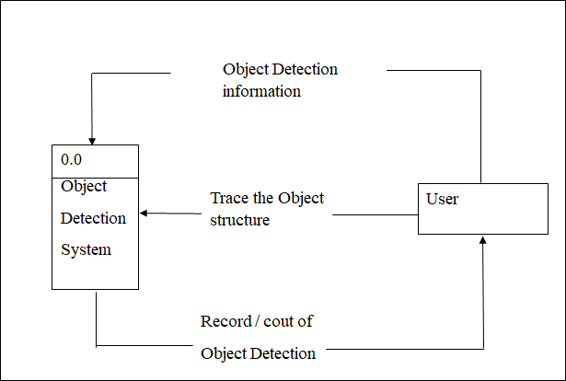

**Level 1 Diagram:** 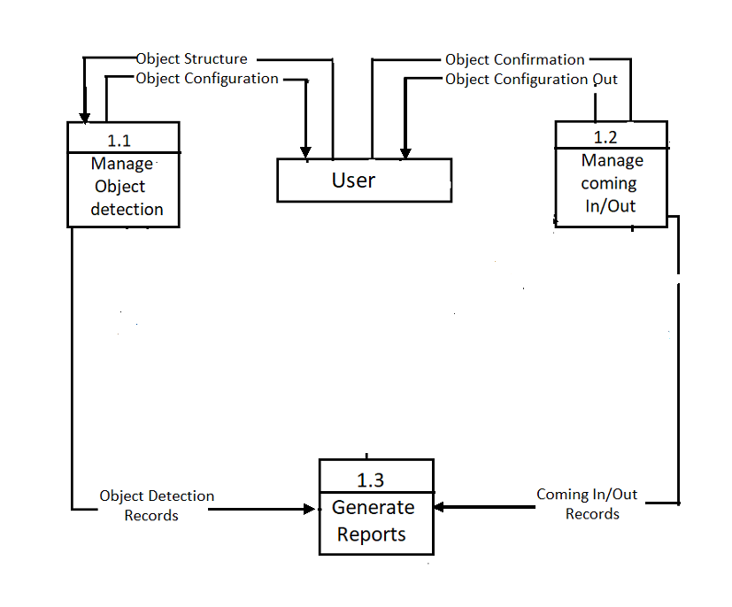

**Level 2 Diagram:**

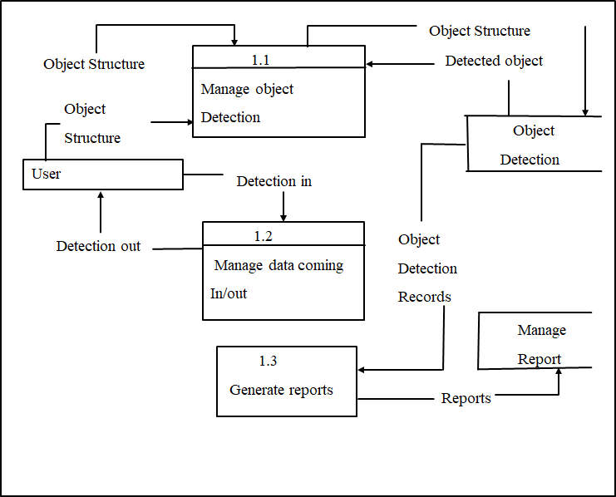

**4.3UML Diagrams**

**4.3.1 Sequence Diagram**

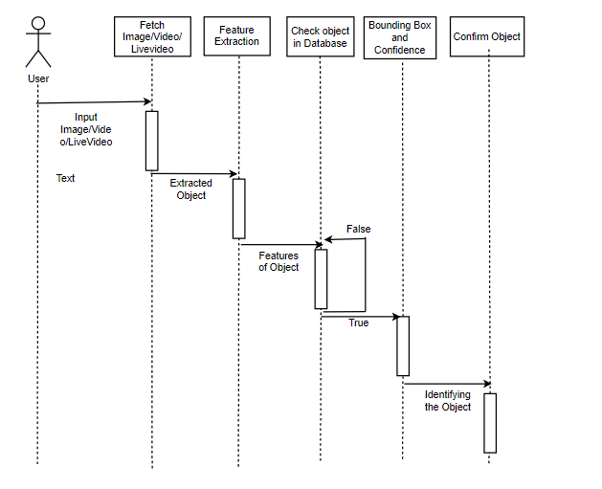

**Fig 4.3.1: Sequence**

**4.3.2 Activity Diagram**

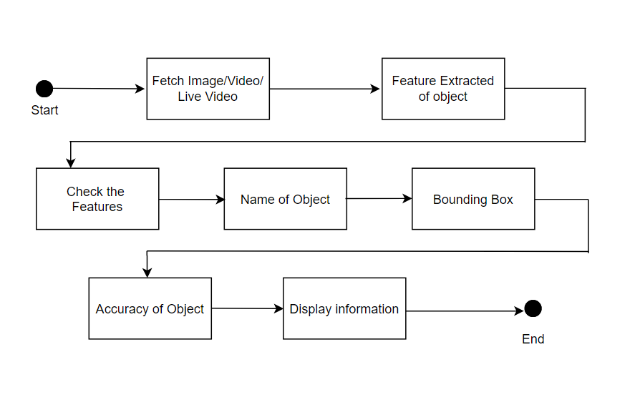**Fig 4.3.4: Activity Diagram**

**Chapter 5**

# MODULE IMPLEMENTATION DETAILS

Implementation is the stage of the project when the theoretical design is turned out into a working system. Thus it can be considered to be the most critical stage in achieving a successful new system and in giving the user confidence that the new system will work and be effective.

The implementation stage involves careful planning, investigation of the existing system and it’s constraints on implementation, designing of methods to achieve changeover and evaluation of changeover methods.

**5.1. Module Description**

**Modules:**

1. **Input module:**
2. **Object Detection Module:**
3. **Output module:**

**1)Input Module:**

The input to the system will be given by the user. The input may be:

I) Image.

II) Video.

III) Live video.

**I) Image:**

The image will be given to the system by loading the image to Jupyter Notebook or by giving the path of image in the system.

**ii)Video:**

The video will be given to the system by loading the video to Jupyter Notebook or by giving the path of video in the system.

**iii)Live video:**

The video will be streamed by using a web-cam of the user PC/system.

**2)Object Detection module:**

In the Object Detection module we import OpenCV and Numpy libraries. The pre-trained weights and model architecture of Yolov3 is loaded to DNN (Deep Neural Network) library present in OpenCV.

Depending on the input of file the further steps are followed:

Step 1: The input image/video/live video is converted to

blob as the network only accepts input as a blob.

Step 2: The blob then is set into a network.

Step 3: As 85 parameters are used for objection detection

in which first 4 are used for bounding box offsets, 1 is

used for confidence and remaining are used for class

prediction as we used COCO dataset which consists

80 names.

Step 4: As one object may contain may bounding boxes we

used NMSbox() function for suppression of boxes.

Step 5: As a multi-dimensional array may formed as one

image consists of many object we use flatten()

function to obtain a one-dimensional array.

Step 6: The image/video/live video is then further

processed and passed to the output module.

**3)Output module:**

The output of Object detection will be shown on an interface created by Juypter Notebook.

**Chapter 6**

# TEST SPECIFICATION

**6.1 Introduction**

The purpose of testing is to discover errors. Testing is the process of trying to discover every conceivable fault or weakness in a work product. It provides a way to check the functionality of components, subassemblies, assemblies and/or a finished product. It is the process of exercising software with the intent of ensuring that the Software system meets its requirements and user expectations and does not fail in an unacceptable manner. There are various types of tests. Each test type addresses a specific testing requirement.

**6.1.1 Objective**

Objective of testing is to verify and validate the product. Major objectives of software testing are: to check that the solution meets user requirements, to find any errors that can be bugs or defects; to determine user acceptability. This is to make confirmation that the system is ready for use to bring confidence in the user.

**6.1.2 What is testing?**

Testing is the process of evaluating a system or its component(s) with the intent to find out whether it satisfies the specified requirements or not. This activity results in the actual, expected and difference between their results. In simple words testing is executing a system in order to identify any gaps, errors or missing requirements in contrast to the actual desire or requirements.

**6.2 Testing Strategy**

Field testing will be performed manually and functional tests will be written in detail.

**Test objectives**

**·**  All field entries must work properly.

· Pages must be activated from the identified link.

· The entry screen, messages and responses must not be delayed.

**Features to be tested**

· Verify that the entries are of the correct format

· No duplicate entries should be allowed

· All links should take the user to the correct page.

**Chapter 7**

# SYSTEM DESIGN AND IMPLEMENTATION

**7.1GUI Screenshots**

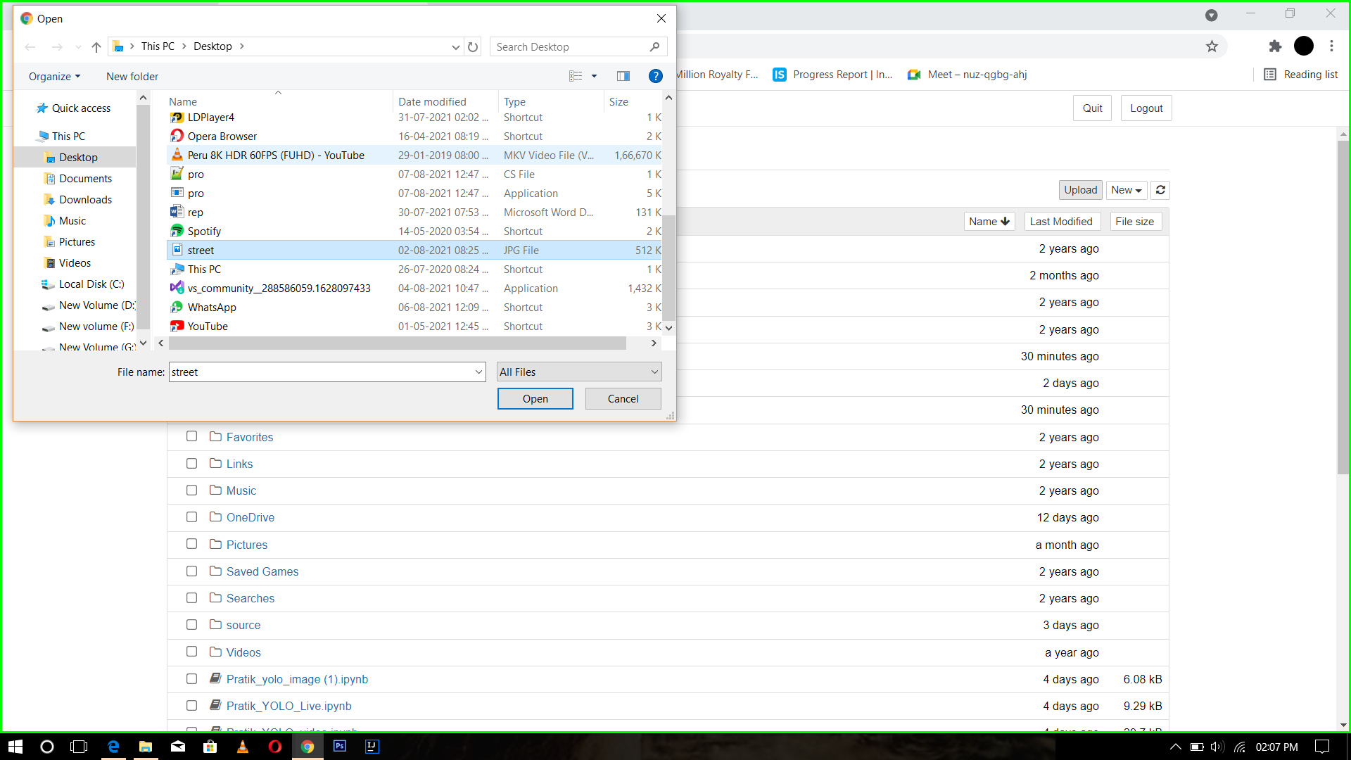

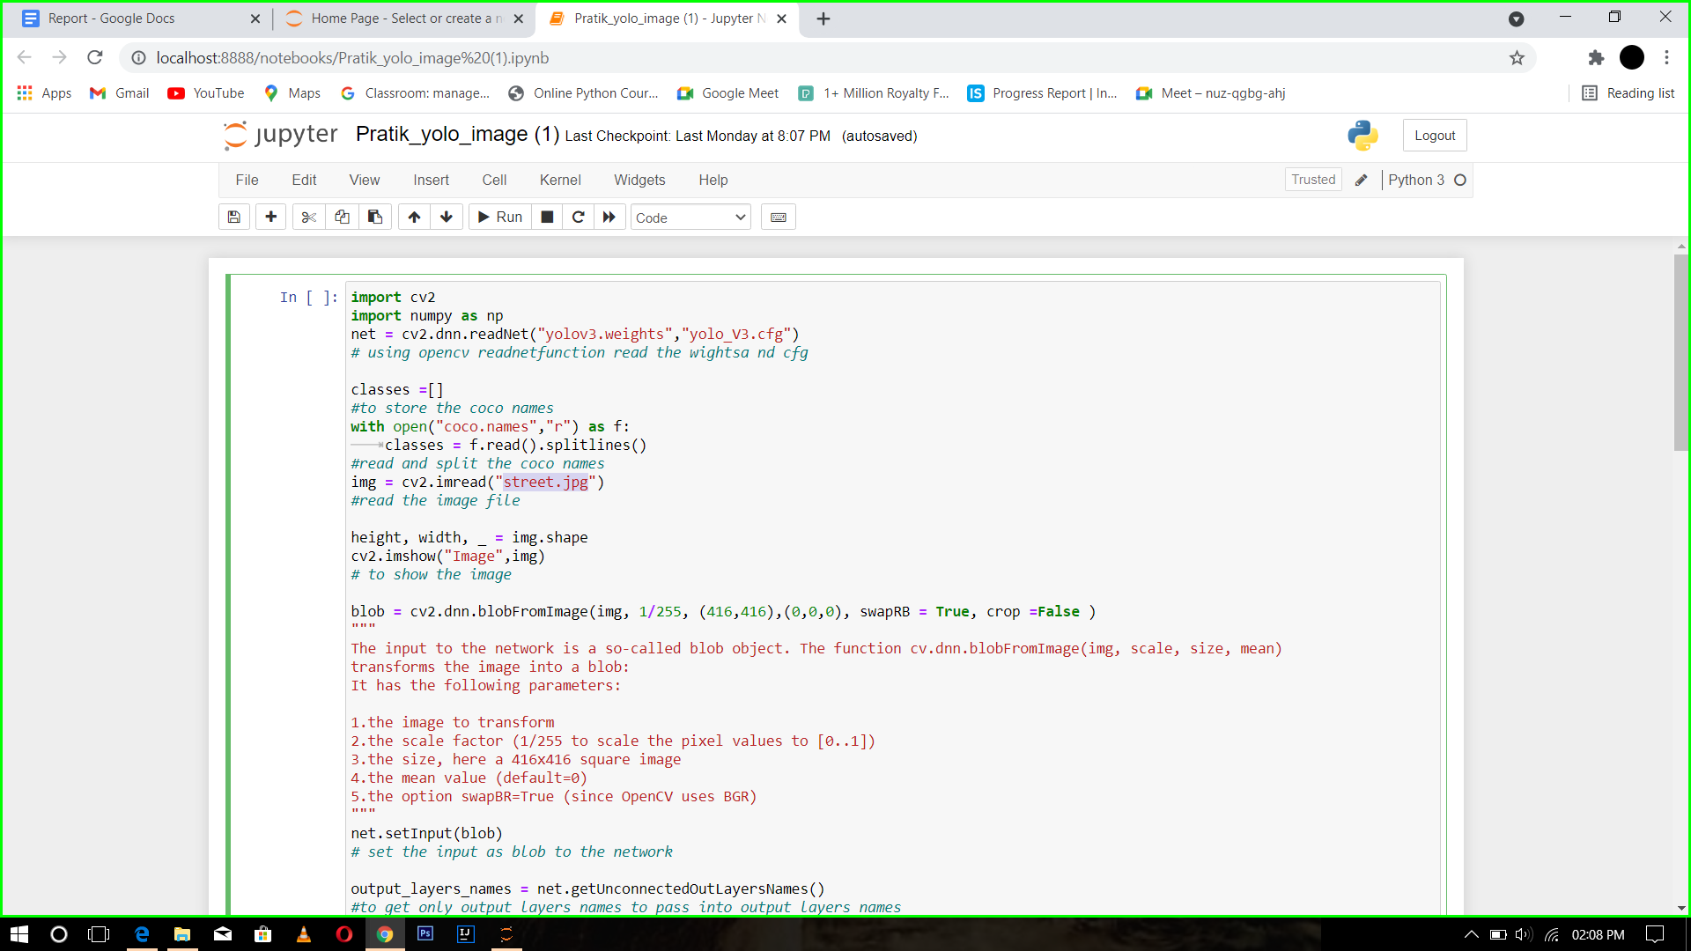

**Figure 7.1: Browse the Image/Video/Live Video.**

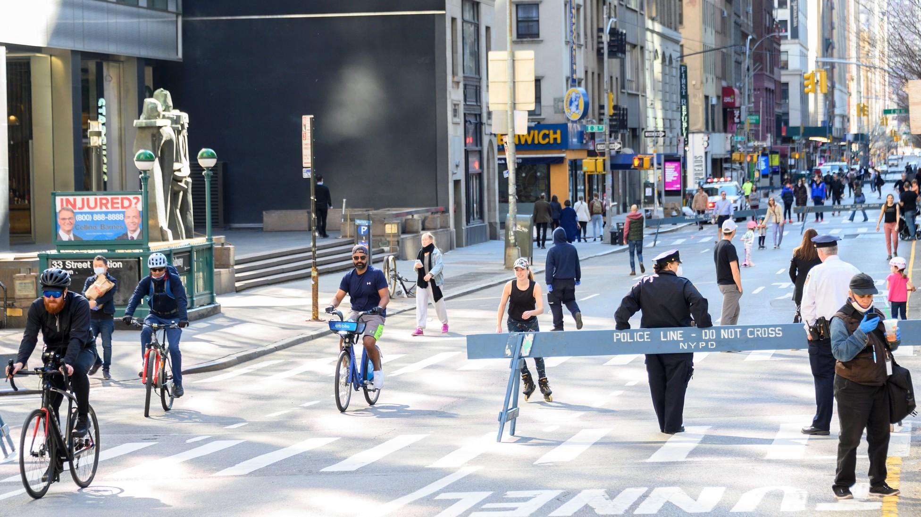

**Figure 7.2.1: Input for Object Detection for Image**

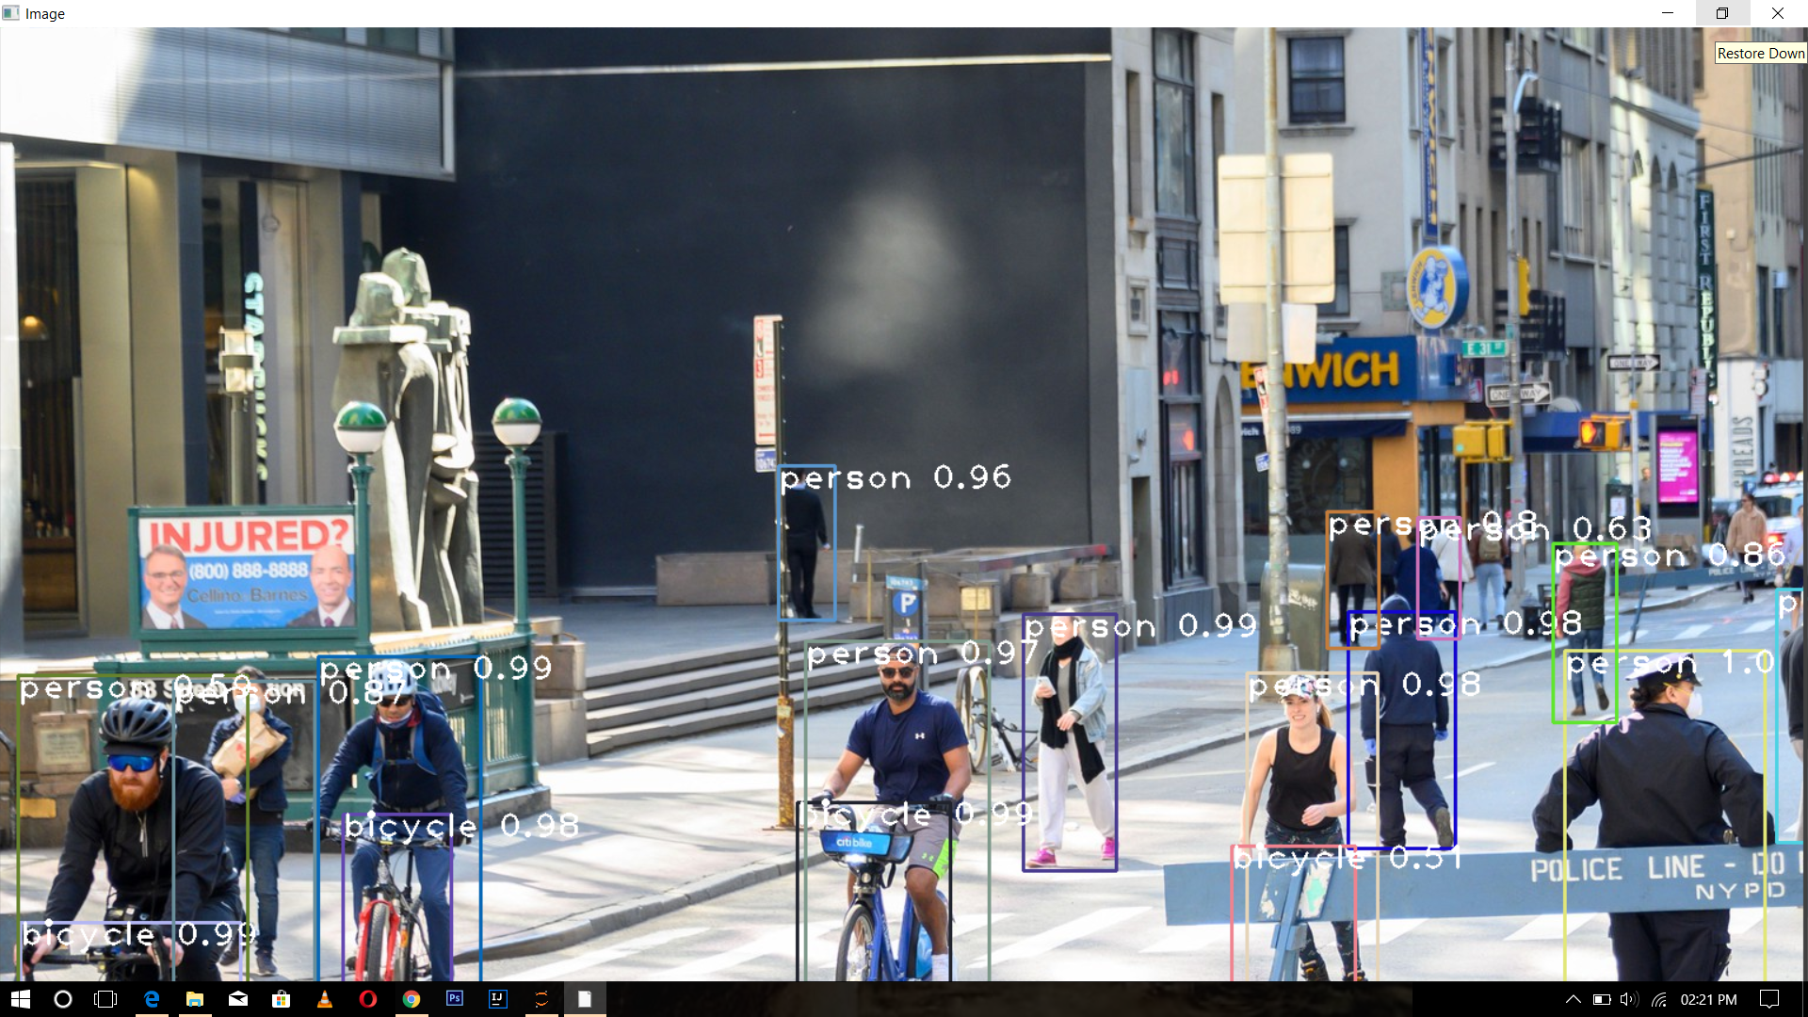

**Figure 7.2.2: Output for Object Detection for Image**

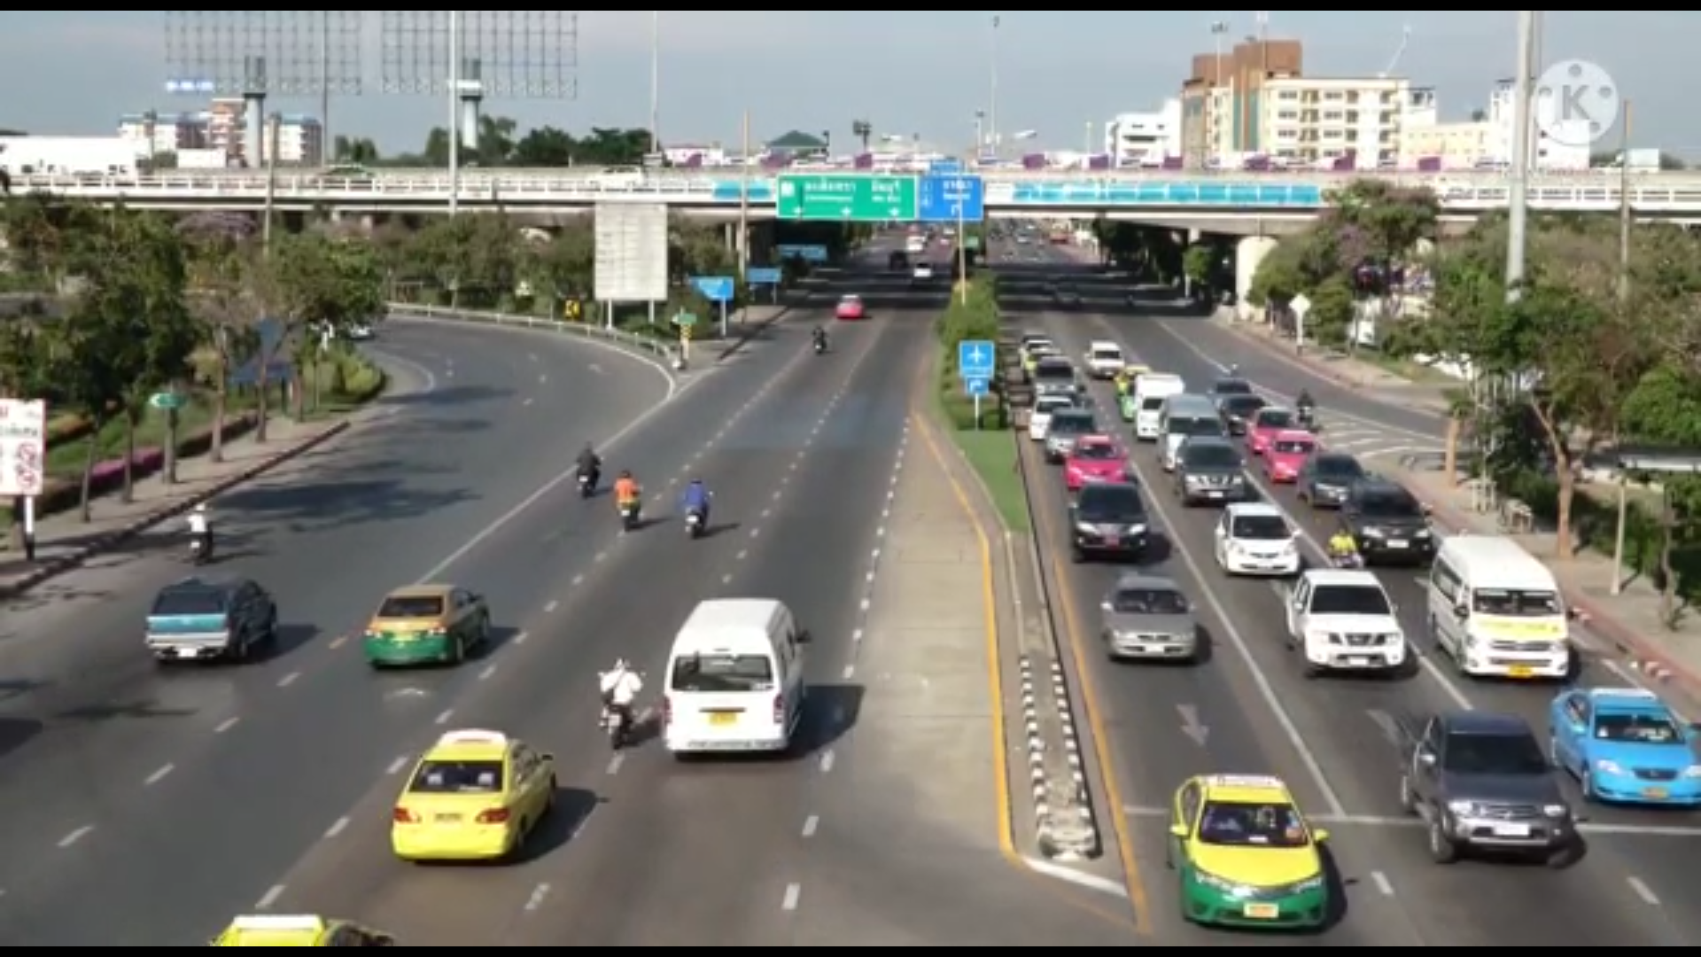

**Figure 7.3.1: Input for Object Detection for Video.**

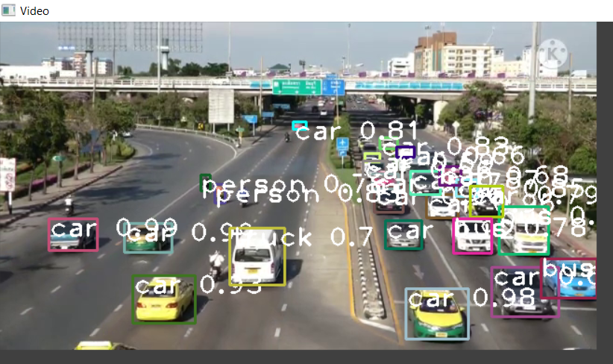

**Figure 7.3.2: Output for Object Detection for Video.**

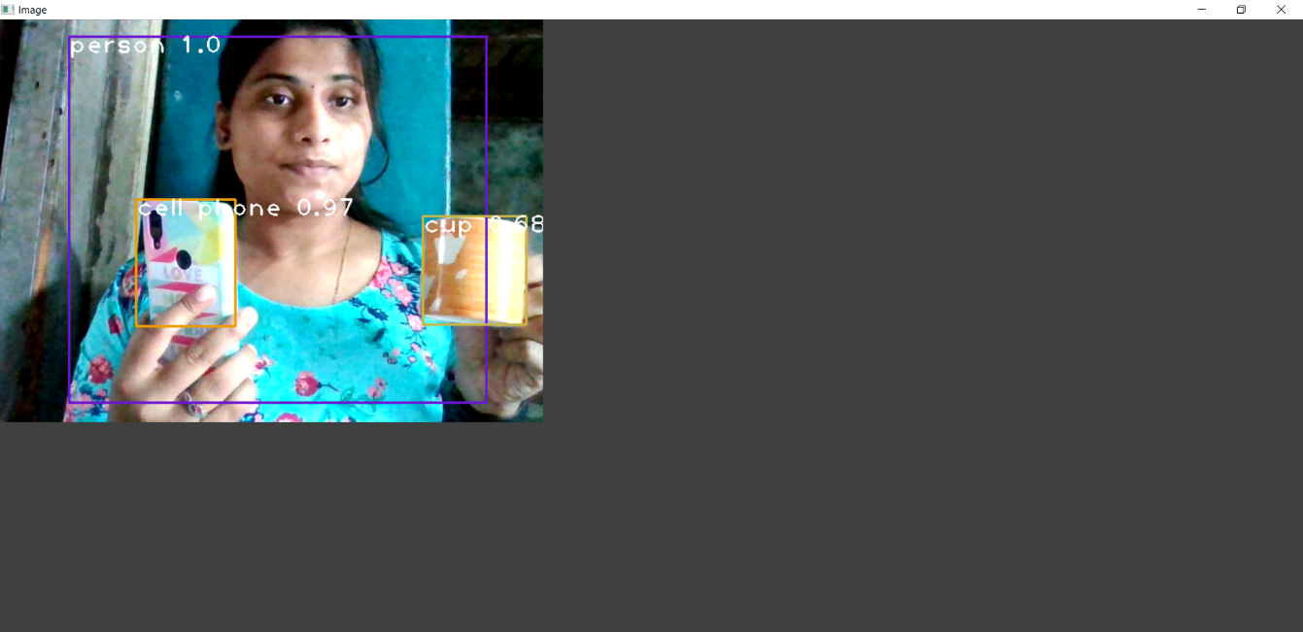

**Figure 7.4: Output for Object Detection for Live Video.**

**Chapter 8**

**CONCLUSION & FUTURE WORK**

**8.1** **CONCLUSION**

The given input i.e. Image/Vide/Live Video is processed and object detection is obtained. Small objects can also be detected using this system, speed and accuracy of the system is also more. About 80 different types of object can be detected

**8.2** **FUTURE WORK**

As the object can detected many objects like people, cars, motorbikes, etc. the project can be further used in traffic analysis, social distancing measurements, it can also be used at border for security purposes.

**REFERENCES:**

[1] Machine Learning Mastery, making developers awesome at Machine Learning, “How to Perform Object Detection With YOLOv3 in Keras”, Published by: Jason Brownlee on May 27,2019 in Deep learning for Computer Version.<https://machinelearningmastery.com/category/deep-learning-for-computer-vision>

[2] Hatem BELHASSEN, Virginie FRESSE, El-Bay BOURENNANE, “Comparative Study of Face and Person Detection algorithms: Case Study of tramway in Lyon” https://www.researchgate.net/publication/ 25 August 2019.

[3] International Journal of Engineering Research & Technology (IJERT) [1], Published by: www.ijert.org “Visual Object Detection and Tracking using YOLO and SORT” Vol. 8 Issue 11, November-2019.

[4] International Journal of Engineering and Advanced Technology (IJEAT) //Geethapriya. S, N. Duraimurugan, S.P. Chokkalingam, “Real-Time Object Detection with Yolo” Volume-8, Issue-3S, February 2019. Published By: Blue Eyes Intelligence Engineering & Sciences Publication.

[5] Yinglong Ma, Muhammad Yahya, Belal Ahmad, Shah Nazir , Amin ul Haq , “Object Detection through Modified YOLO Neural Network Tanvir Ahmad” //Hindawi Scientific Programming Volume 2020, Article ID 8403262,https://doi.org/10.1155/2020/8403262